**Trader manual guide.**

Trader Login

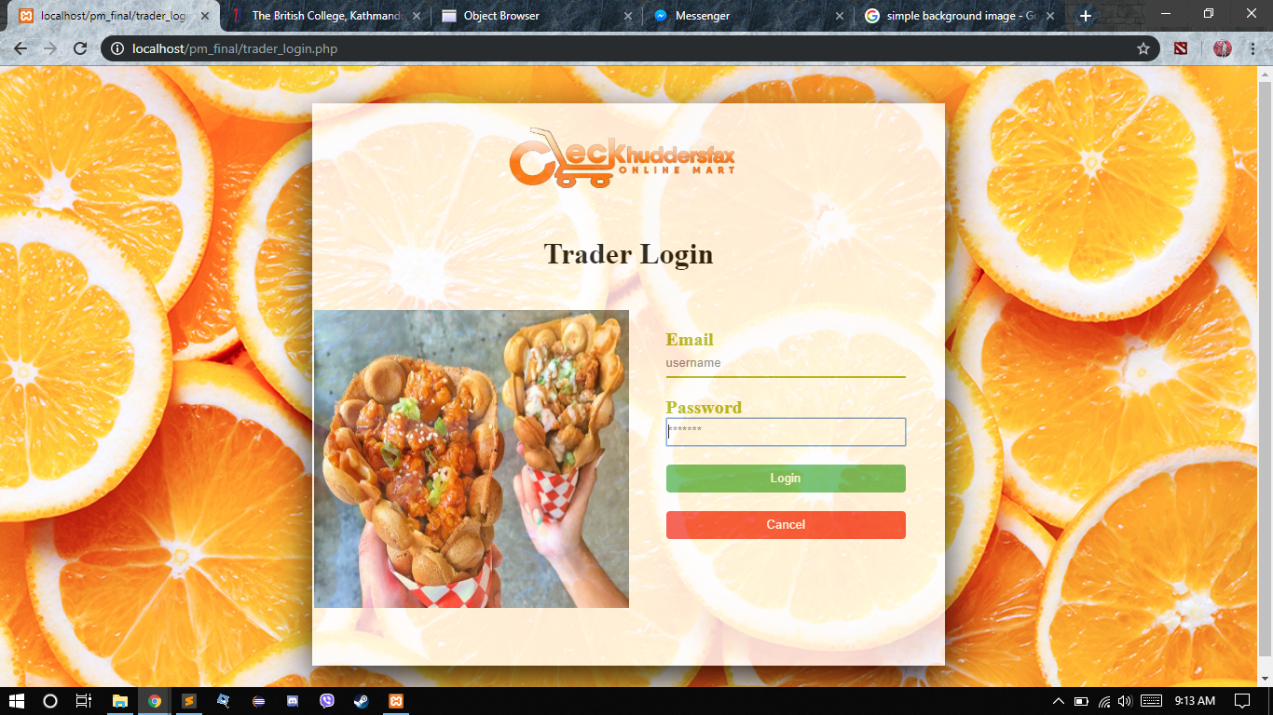

The trader should login from the login page by using their email and password and click on the Login button to enter the trader dashboard.

Trader Dashboard

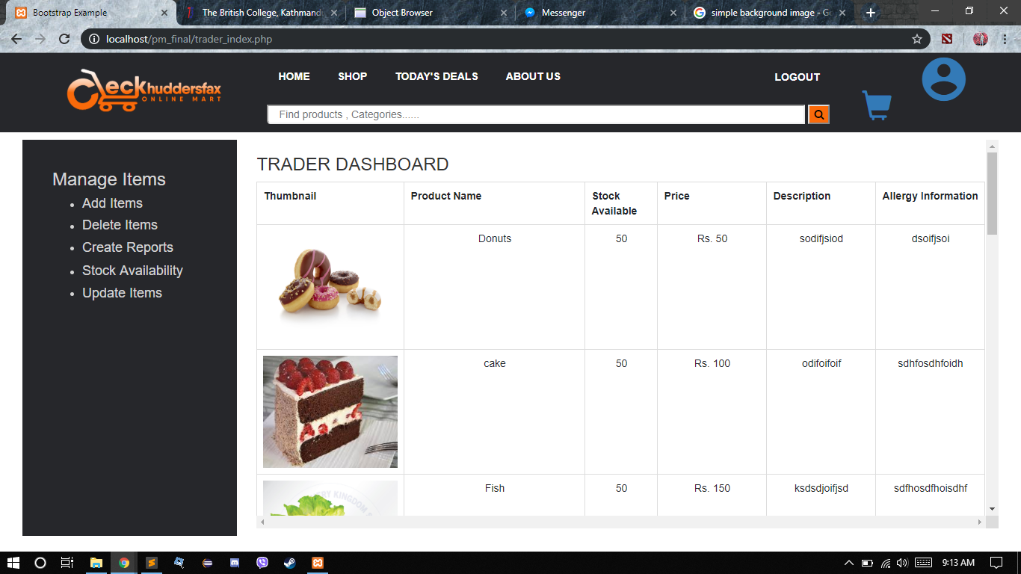

Trader Dashboard will show the trader about their product detail.

Add Items

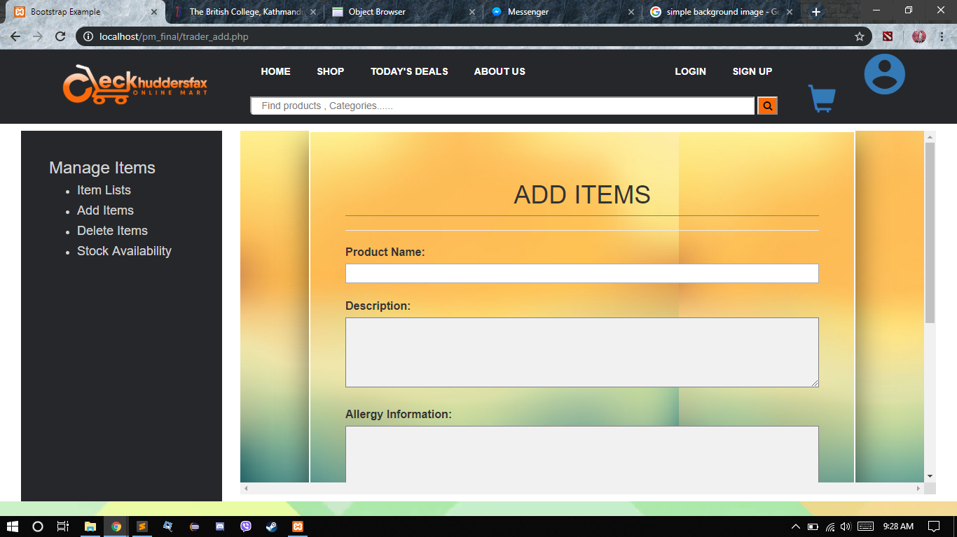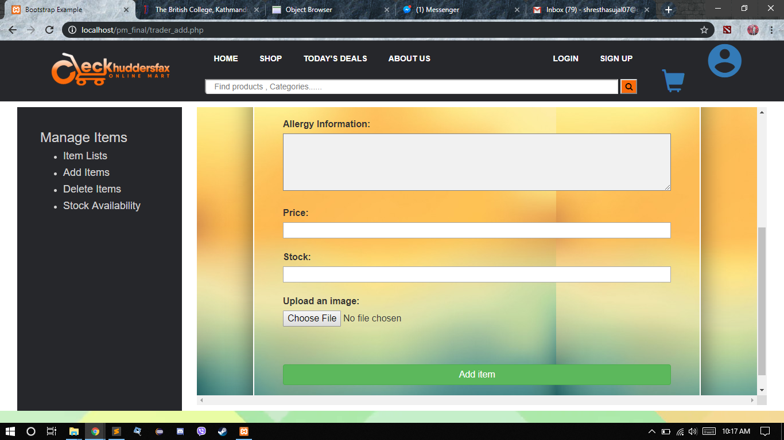

Trader can then add their item from here by giving the information about the product that is name, description, allergy information, price, stock, up and putting up the image which will then add item in the shop.

Delete Items

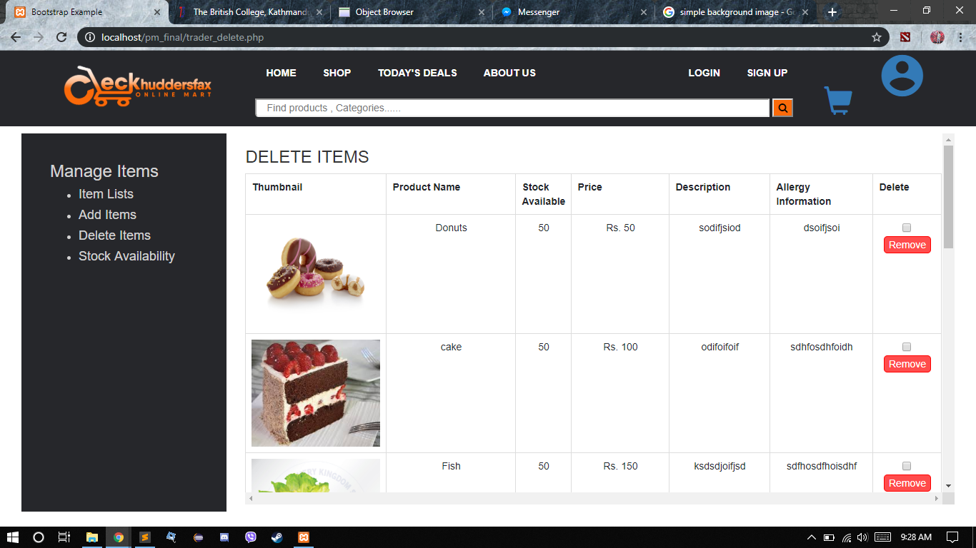

You can delete one product at a time or multiple products all at once from your shop.

Stock Availability

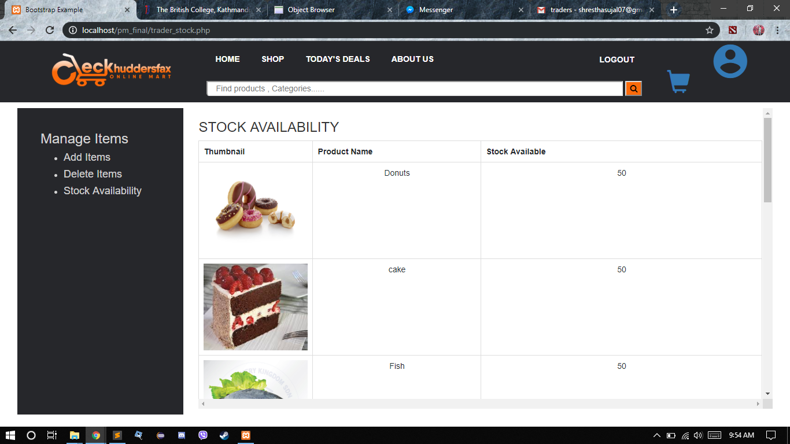

Traders can also update their stock accordingly to the items they have.